Extracts from Wireshark Measurements
1) Absence of SDLC Response Following a Synchronization Request

Comment:
This extract from the measurement file “No SDLC Response” highlights that, in the absence of a response from the Slave to the SDLC synchronization request, the Master repeatedly retransmits the request after the expiration of the timer
T_out_sdlc_m ≈ 10 s.

2) SDLC Retransmission After FRMR Rejection
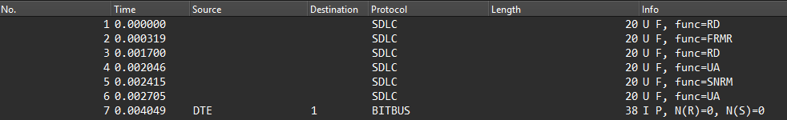

Comment:
As shown in the extract from the file “Wrong_CS”, during the resynchronization phase, the Master sends a new SDLC connection request. However, the Slave retains its previous NRM state.
Upon receiving the RD frame, the Slave rejects the request by sending an FRMR frame and then transitions to the NDM state.
In this case, the Master sends a DISC frame again (noted as RD in the measurements) in order to properly re-establish the SDLC connection. The Slave responds with an acknowledgment, allowing the procedure to complete and Bitbus communication to resume.

3) Absence of Software Response Following a Bitbus Communication Attempt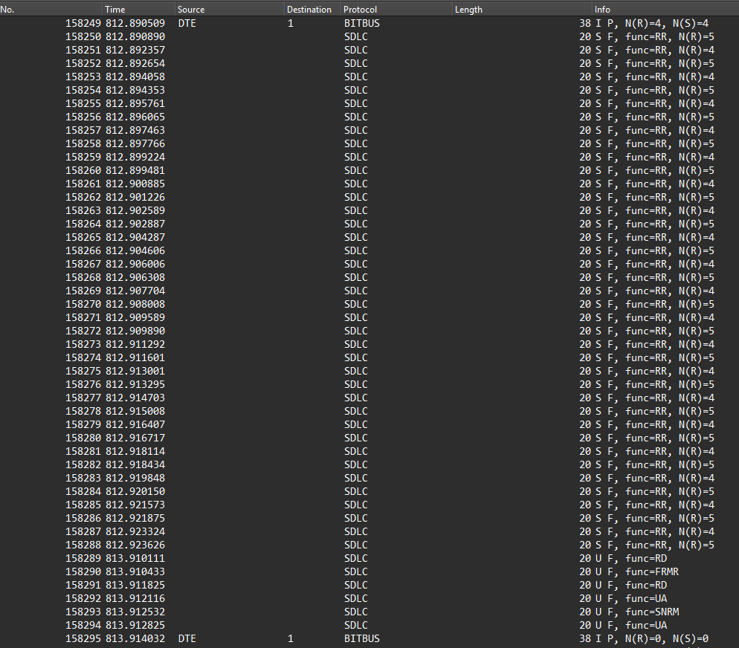

Comment:
According to the extract from the measurement file “No Bitbus Response”, we observe that at
t = 812.890509 s (Frame No. 158249), the Master sends a software request for a Bitbus exchange.
After the timeout expiration defined as:
$$T_{out_M}=t(\text{Frame No. 158288})-t(\text{Frame No. 158249}) \\ =812.923-812.890=0.03\text{ s}=30\text{ ms}$$
corresponding to approximately 0.032 s, no response is received.
The Master then enters a reinitialization phase lasting approximately 1 s, corresponding to T_reset as modeled in UPPAAL.
After this reinitialization phase, a new resynchronization phase is initiated in order to start a new frame exchange.

Absence of Response to a Link Request

Comment :
In the measurement file “No Link Response”, after successfully establishing an SDLC connection, a test was performed with:
$$T_{polling}=0.002\text{ s }(2\text{ ms})$$
to send a link request.
After three successive attempts, each marked by a timeout expiration
T_out_sdlc_m ≈ 10 s, the system reports a Bitbus communication error to the user.
The absence of response following an unlink attempt follows almost the same logic, as shown in the file “No Unlink Response”, where the three unlink attempts correspond to frames No. 427, No. 847, and No. 1225.

Master Reaction After Receiving an Incorrect Checksum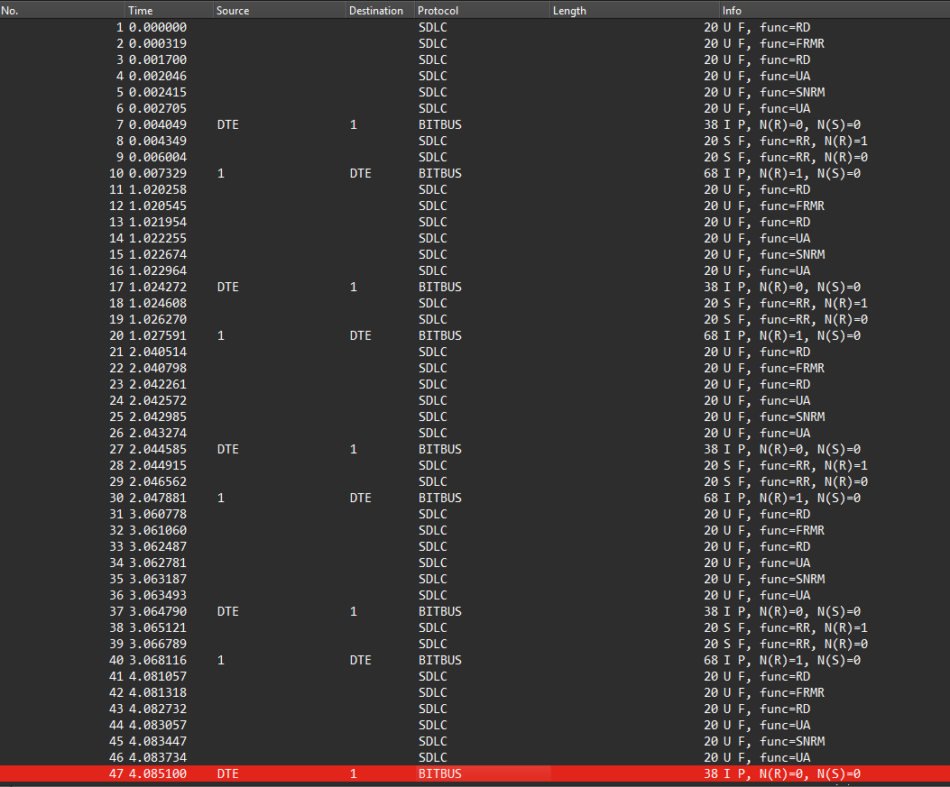

As shown in the extract from the file “Wrong_CS_detected_by_Master”, after receiving a frame containing an incorrect checksum value, the Master enters a reinitialization phase.
This explains the resynchronization attempt observed at:
$$t=1.02\text{ s}$$
This value corresponds to the sum of the timers:
$$T_{polling}+T_{reset}=0.02+1\text{ s}$$

